Doc. No : KAF-22 | 2024.01

Guide for using the certification mark and logo
For Clients certified under UAF – United Accreditation Foundation
(United Accreditation Foundation)

1. General rules for use of the KVQA/UAF certification mark and logo
- KVQA/UAF Mark and logo may only be used by the certified client and only in direct connection with the company's name or company mark of the certified client. It may not be affixed to the applicant's products or used in relation to applicant's products and/or processes. Use of the mark shall be restricted to the holder of the permission to do so and may not be transferred by the applicant to the third parties without the express permission of the certification body.
- The KVQA/UAF mark may only be used in the extent of printings or advertising materials like internet, brochures, or other related documents relevant to the certification scope addressed in the certificate.
- When the mark is used in general advertisement, the certification scope shall be addressed on it. It is not permitted use of a certification document or any part thereof in a misleading manner and should cover the the type of management system (e.g. quality, environment) and the applicable standard.
- The KVQA/UAF mark and logo may only be used in the form shown. The original marks may be enlarged or reduced in size, but its size shall not be smaller than 10mm.
- When the certification mark is used with its copy or printing, the colors of the mark follows those as shown in the figure in principle, and shall be in one color.
- If the applicant has further questions concerning the use of the certification mark, he is obliged to get the written approval by KVQA before using it.
- Accreditation body or it’s member can visit your company along with the certification body.
- The Logo Shall not be used on product product packing, inspection report, Laboratory report and Calibration Certificates. The statement shall in no way imply that the product, process or service is certified by this means. The statement shall include reference to:
— identification (e.g. brand or name) of the certified client;
— the type of management system (e.g. quality, environment) and the applicable standard;
— the certification body issuing the certificate is KVQA.
2. Misleading of the certification mark and logo
- When the certification mark and logo is misused, the 'corrective action report' addressed the corrective action and its deadline will be sent to the applicant. When the scope is reduced or extended the client will amend the advertisement.
- The applicant shall submit the result of the corrective action taken to KVQA within one month from CAR is drawn up.
- If the applicant does not take the CAR, KVQA can require corrective action to the applicant in writing.
Afterward the corrective action is not taken within given period, the certification can be cancelled upon the decision of KVQA certification committee. At this time the certificate shall be returned to KVQA and the publication of the transgression, if necessary, can be taken.
- If the applicant uses the certification mark and logo after its cancellation or suspension, legal action can be taken. The mark do not permitted to be applied to lab test, calibration or inspection report since these are the products at such organization.
- FSMS certification mark on the product nor the product packaging. In the context of this document, product packaging referred to in ISO 17021-1:2015, 8.3, shall cover product packaging, both primary packaging (which contains the product) and any outer or secondary packaging.

- It is not permitted the use of any statement on product packaging that the client has a certified FSMS. This includes all product packaging, both primary packaging (which contains the product) and any outer or secondary packaging
3. Corrective action: The result of corrective action taken for non-conformity drawn up in surveillance audit shall be submitted and approved within one month from the date it is drawn up. Otherwise, the certification can be suspended.
Even though the certification is suspended for the above reason, if it is clear that the applicant does not take the follow-up action for it, the certification can be cancelled.
4. Duties of the applicant
- The certification shall remain valid for a period of three years. The surveillance audits shall be performed in accordance with the schedule suggested by KVQA during the period.
- The applicant is obliged, once the certificate has been awarded, to notify the certification body of all important changes to his management system and changes to the company's structure and the organization which have a major influence on the management system.
- The above guide for the use of the certification mark and logo shall be always complied and subject to legal action on non-conformances or misuse of logo.
4) The client does not use or permit any misleading statement regarding the certification or certification
documents any part there off.
5) The client upon suspension or withdrawal of its certification discontinues its uses on all advertising
material and amends if the scope is reduced.

Client shall not use the logo to imply that the certification applies to activities and sites that are outside the scope of certification.
Following is the illustrations used for using the logo on the advertising material as described above

- FOR QMS UNDER UAF ACCREDITATION
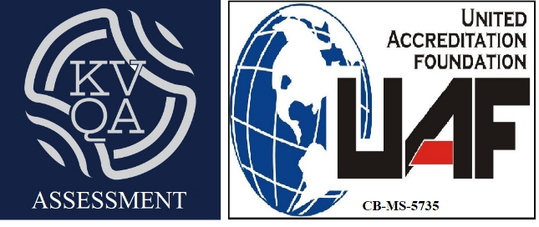

- FOR ISMS UNDER UAF ACCREDITATION
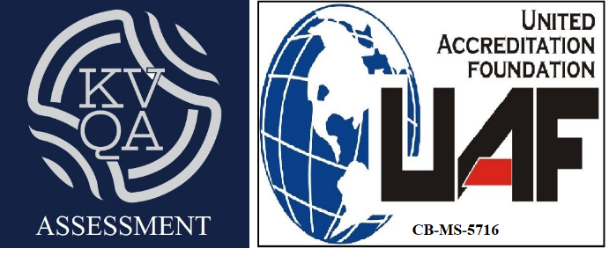

- FOR FSMS UAF ACCREDIATTION

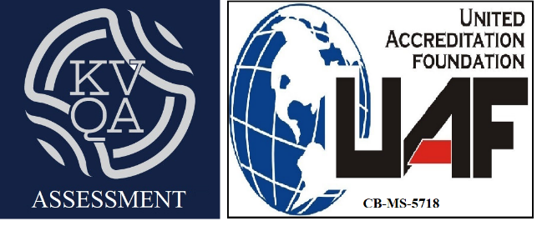

- FOR EMS UNDER UAF ACCREDITATION

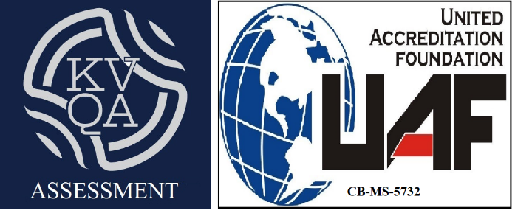

- FOR OHS UNDER UAF ACCREDITATION

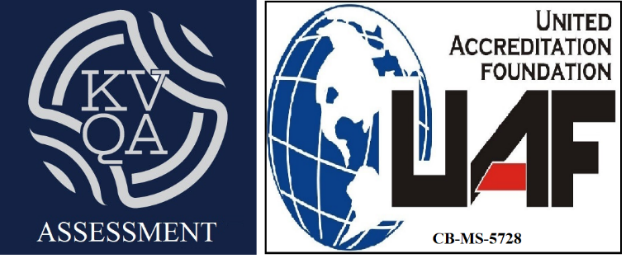

- FOR PIMS UNDER UAF ACCREDITATION

